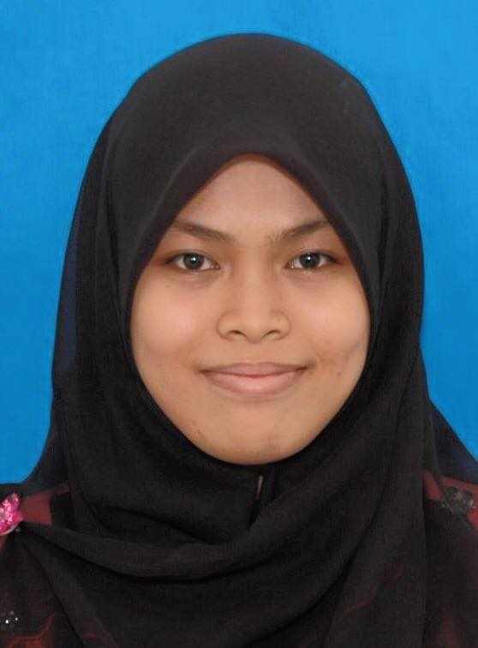

**PERSONAL DETAILS**

Full Name : NUR ATHIRAH BINTI JUHAILI

New I/C : 950712-10-5388

Date of Birth : 12 JULY 1995

Place of Birth : AMPANG, SELANGOR

Marriage Status : SINGLE

Nationality : MALAYSIAN

Religion : ISLAM

Home Address : NO. 13 LORONG NALURI SUKMA 8/7 BANDAR

PUNCAK ALAM, 42300 KUALA SELANGOR, SELANGOR

Telephone No : 011-33628640

E-mail Address : [nathirah1207@gmail.com](mailto:nathirah1207@gmail.com)

**EDUCATIONAL BACKGROUND**

**2014-2018** : ***Bachelor of Electrical & Electronic Engineering (Hons)***

Faculty of Electrical Engineering

UiTM Shah Alam

**2013-2014** : ***Matriculation College***

Negeri Sembilan Matriculation, Kuala Pilah

**2011-2012** : ***Sijil Pelajaran Malaysia (SPM*)**

Sekolah Menengah Kebangsaan Puncak Alam

**2008-2010** : ***Penilaian Menengah Rendah (PMR)***

Sekolah Menengah Kebangsaan Puncak Alam

**2006-2007** : ***Ujian Percapaian Sekolah Rendah (UPSR)***

Sekolah Kebangsaan Puncak Alam (2)

**2003-2005** : Sekolah Kebangsaan Puncak Alam

**2002-2003** : Sekolah Kebangsaan Sungei Way, Petaling Jaya

**ACADEMIC RESULT**

UPSR : 5A

PMR : 8A

SPM : 4A, 3B, 2C

MATRICULATION : 3.23

MUET : 3

CURRENT CGPA : 2.22

**PERSONAL SKILLS**

**Languages**  : Malay Languages (Written and spoken)

English Languages (Written and spoken)

**Computer Skills** : Microsoft Word 2003/2007/2010

Microsoft Power Point 2003/2007/2010

Microsoft Excel 2003/2007/2010

LTspice IV

.

**Personal Qualities** : Hardworking person

Obey to instruction and order well

Supportive person

Can work under stress and pressure

Communicate well

**Self-Strengths** : Committed to career

Focus

Caring to other co-worker

Co-operative

Highly motivated

Independent

**WORKING EXPERIENCES**

**2013-2014** : Staff of Tuition Centre (Pusat Tuisyen Permata Hati)

Key in and editing data of student’s payment and reputation.

Arranged, cleaning and closing tuition centre.

**2016-now** : Cashier at KFC Seksyen 2 DT, Shah Alam

Handle, operator, cash in and prepare food for customers.

Arranged stock at rack.

**CO-CURRICULUM**

1. Night Run (2.5KM)
2. Zumba Night (Pusat Sukan UiTM Shah Alam)
3. Cleaning Pantai Jeram (National Leader Club UiTM Shah Alam)
4. Kesatria UiTM Shah Alam

**REFERENCES**

Encik Fadhil

Pusat Tuisyen Permata Hati

Fasa 2, Puncak Alam

42300, Kuala Selangor

Selangor, Malaysia

Tel: 013-3456706

Manager Miss Sobihah

Drive Thru KFC Seksyen 2

Lot 2, Jalan Bunga Melur 2/18,

Seksyen 2, 40000 Shah Alam,

Selangor, Malaysia

Tel: 019-3361536

Mrs. Norhayati Hamzah

Koordinator Latihan Industri

Fakulti Kejuruteraan Elektrik

Universiti Teknologi MARA

40450 Shah Alam

Tel: 03-55436051/5107/5072